WEEKLY INTERNSHIP PROGRESS REPORT
Intern: Renu Gehlot
Institution: MBM University, Jodhpur
Project Title: AI-Based PDF Chatbot Development Using Retrieval-Augmented Generation (RAG)
Reporting Period: Week 5 (Day 19 – Day 23)

Weekly Summary
During this week, I focused on the development of the offline version of the AI-Based PDF Chatbot. The major objective was to understand and implement local Large Language Models (LLMs) using Ollama. I successfully completed the coding for the offline chatbot phase, installed and configured the required libraries, explored bilingual chatbot functionality, and completed the second phase of the project. Additionally, I studied the objectives and workflow of Phase 3 to prepare for the next stage of development.
This week's activities enhanced my understanding of offline AI deployment, bilingual chatbot implementation, local model execution, and project architecture. Practical implementation using Ollama helped me understand how AI applications can operate efficiently without relying on cloud-based APIs.

Detailed Progress

Day 19: Understanding Ollama and Local LLMs

Activities Performed
- Explored the working of Ollama.
- Studied how local Large Language Models (LLMs) can run without an internet connection.
- Learned the advantages of offline AI systems.
- Understood the workflow of local model inference.

Learning Outcomes
I gained a clear understanding of offline language models and how Ollama enables local execution of AI models while ensuring better privacy, reduced operational costs, and independence from cloud services.

Day 20: Ollama Installation and Environment Setup

Activities Performed
- Installed and configured Ollama.
- Installed all required Python libraries and project dependencies.
- Verified successful installation of the development environment.
- Reviewed the project code and overall architecture.

Learning Outcomes
This activity helped me understand the setup process required for offline chatbot development. I also became familiar with dependency management and project configuration.

Day 21: Offline Chatbot Implementation

Activities Performed
- Developed the code for the offline chatbot phase.
- Connected the local language model with the chatbot workflow.
- Tested the execution flow of the offline implementation.
- Verified communication between different project modules.

Learning Outcomes
I gained practical experience in implementing an offline chatbot architecture and understood how local language models interact with the Retrieval-Augmented Generation (RAG) pipeline.

Day 22: Project Phase Completion

Activities Performed
- Successfully completed Phase 2 of the project.
- Reviewed the completed implementation.
- Studied the objectives and architecture of Phase 3.
- Planned the upcoming implementation tasks.

Learning Outcomes
Completing Phase 2 improved my understanding of the project lifecycle and prepared me for integrating additional features in the next phase of development.

Day 23: Bilingual Chatbot Development

Activities Performed
- Implemented the bilingual language functionality.
- Worked on the code required for supporting multiple languages.
- Tested the bilingual processing workflow.
- Explored methods for improving multilingual chatbot responses.

Learning Outcomes
I learned how bilingual functionality can improve chatbot usability by enabling communication in multiple languages. This activity also enhanced my understanding of multilingual AI applications and language processing.

Outcome of the Week
By the end of this week, I successfully completed the second phase of the AI-Based PDF Chatbot project. I gained practical experience in installing and configuring Ollama, implementing offline chatbot functionality, and developing bilingual language support. I also explored the working principles of local Large Language Models (LLMs) and understood how they can be integrated into Retrieval-Augmented Generation (RAG) systems without requiring cloud-based APIs.
The knowledge gained during this week has strengthened my understanding of offline AI systems and prepared me for implementing the advanced features planned in Phase 3 of the project.

Resources Used

YouTube Channels
- freeCodeCamp
- CodeWithHarry
- NetworkChuck
- Tech With Tim

Documentation
- Ollama Documentation
- LangChain Documentation
- Streamlit Documentation
- Hugging Face Documentation
- Python Documentation

Work Evidence / Screenshots
The following screenshots are attached as evidence of the practical work completed during the week:
- Figure 1: Installation and configuration of Ollama.
- Figure 2: Installation of required Python libraries.
- Figure 3: Offline chatbot code implementation.
- Figure 4: Overview and debugging of project code.
- Figure 5: Completion of Phase 2.
- Figure 6: Bilingual chatbot implementation and testing.

Challenges Faced
- Understanding the workflow of local language models.
- Configuring Ollama correctly for offline execution.
- Managing dependencies for offline deployment.
- Implementing bilingual language support.
- Ensuring smooth integration between local models and the chatbot pipeline.

Solutions Implemented
- Referred to official Ollama documentation.
- Studied tutorials on offline LLM deployment.
- Tested each module individually before integration.
- Verified library compatibility and project configuration.
- Reviewed the complete project architecture before implementing new features.

Plan for Next Week
- Begin implementing Phase 3 of the project.
- Improve bilingual chatbot performance.
- Optimize offline response generation.
- Enhance retrieval accuracy.
- Test the chatbot with larger PDF documents.
- Improve user interface and chatbot performance.
- Perform end-to-end testing of the offline PDF chatbot.
- Prepare the project for final integration and demonstration.
1)Libraries installed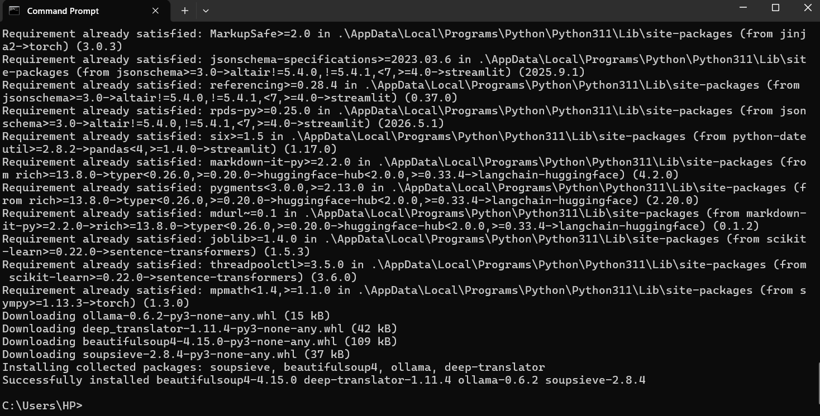

2)Online Chatbot
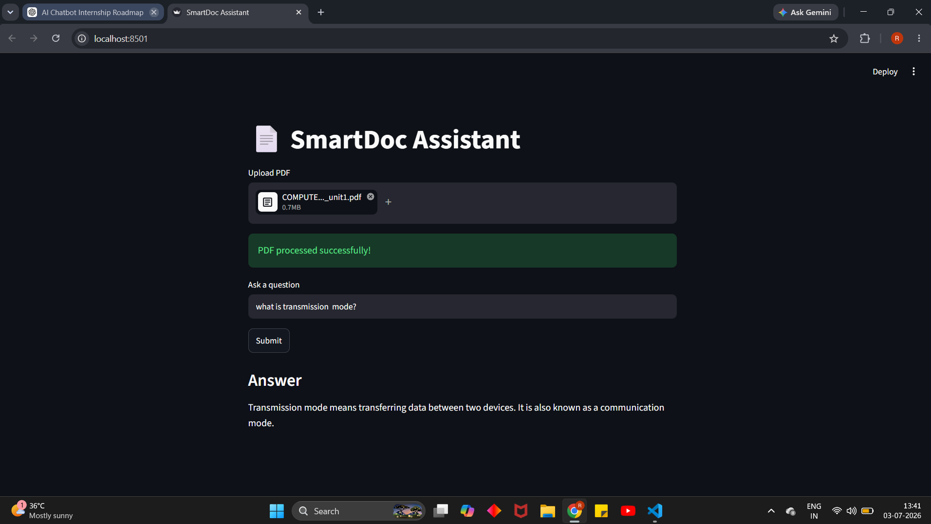
3)Offline chatbot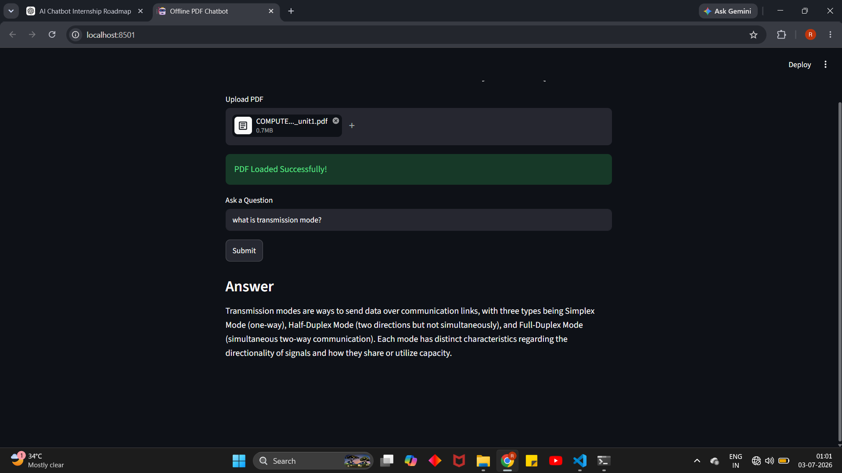

4)Bilingual Chatbot